**EEI3346 – WEB APPLICATION DEVELOPMENT**

**Mini Project - Documentation**

**Name - H.S.S. Wijethunga**

**Student Number- S92062866**

**THE OPEN UNIVERSITY OF SRI LANKA**

**BACHELOR OF SOFTWARE ENGINEERING**

**ACADEMIC YEAR – 2021/22**

**CONTENT**

1. Introduction
2. Frontpage
3. Design of the system
4. Architectural diagram of the system
5. Site map
6. Problems occurred
7. Solutions for the problems
8. Web technologies
9. Results (Screenshots of the system)
10. References
11. Conclusion
12. **Introduction**

The assignment is to create a website that displays Tourist information about Sri Lanka.

**Task 1: Web Design**

This must contain all the well-known tourist places. It can be named “Pearl of the Indian Ocean” and it should contain an appropriate theme. Users could be able to browse Province/District wise information as well, it would be appreciated if we add other details like general information of Sri Lanka and contact details of the service providers, etc.

The assignment’s page contains at least five web pages and it should be attractive. Some suggestions for pages are Home, about us, separate pages for tourist information, queries, To-Do List, and Contact Us.

**Task 2: Documentation**

The documentation should describe your implementation covering the following areas.

1. Frontpage (with your basic details)

2. Problem(s) – sub-problems, constraints

3. Solution Approach - How you plan to solve the identified sub-problems

4. Architectural diagram of the system

5. Site Map

6. Used web technologies and examples

7. Test Results (test cases with screenshots and descriptions)

8. Conclusion

1. **Frontpage**

The front page of the site is crated with more ways to see the tourism places of each province. On the top of the page, there are five options like Home, Places to travel, To-Do, Contact Us, and About us.

Users can go to the ‘Provinces’ page clicking up ‘Places to Travel’. Users can select any province that they want and see the tourism places of that province.

Then users can find to do option next to the option of places to travel. After that users can see the contact us option and users can see our Facebook, Instagram, Twitter, Telephone number, and Email address there.

Users can contact us through those links. Then, users can see the About us option next to the Contact us option.

There is a small description about Sri Lanka on the left side of the page and at the bottom of the page, users can see Explore button, Watch now and Learn more.

Users can go to the Provinces page through the Explore button and know more information about Sri Lanka by clicking Watch Now and Learn More.

**3. Design of the system**

The site is created with the most important tourist places in the present. The places are described with essential information of the places and including the pictures of the places.

Users can know more if he/she wants by clicking ‘know more’ of each place. The button to see the map is included on each and every page so, users can see the map if they want to get an idea about these tourism places and provinces of these places.

When users visit the home page (front page) they can go to the provinces page to see the information about places of each province by clicking ‘Places to Travel’ and ‘Explore’. All the pages are included an option to come back to the home page and every page that includes the information of tourism places, are included an option to come back to the ‘Provinces’ page also.

In the same way, this site is created without using Navigation bar Horizontal bar. The home page is created with buttons to go to others pages.

To Do page is created with Vuejs and Users can see the provinces and the tourist attraction places of those provinces. So, users can select the places that they want to visit and when users select a place, it will be automatically added to the To Do list.

1. **Architectural diagram of the system**

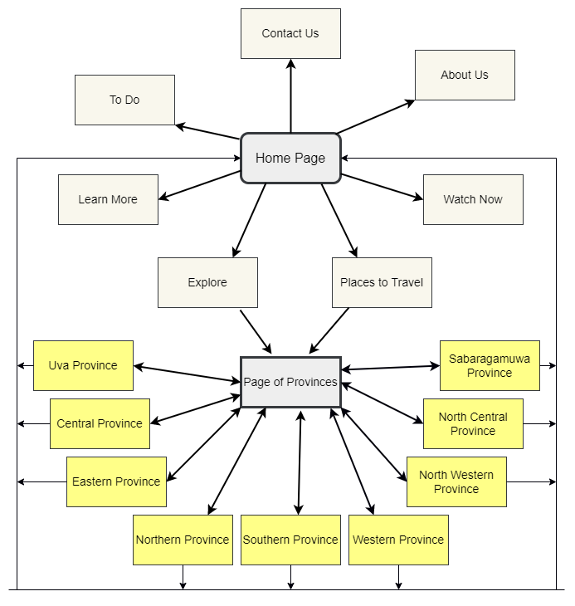

1. **Site map**

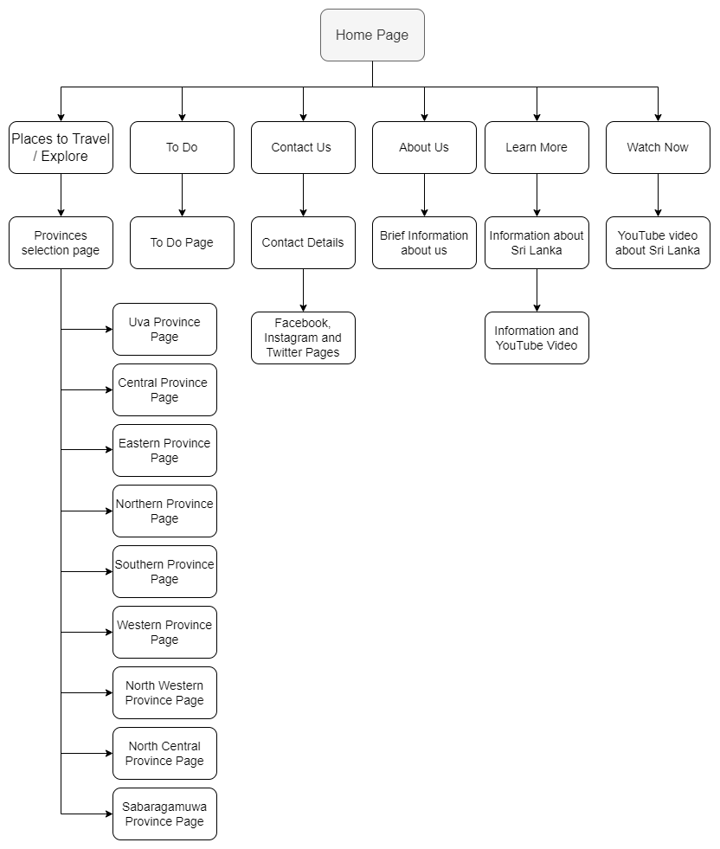

1. **Problems occurred**
2. Creating an attractive home page
3. Dividing places as provinces
4. Creating the pages of provinces
5. Creating To Do list
6. **Solutions for the problems**
7. Creating a different home page with more options to go for other pages of the site
8. On the provinces page, each province has been divided as a gallery.
9. Every province page has been created with options for going home page and provinces page. Also, users can see the map.
10. To Do page is created with HTML, CSS, and Vuejs. Users can select the places that they want to visit and the places user clicked, are automatically added to the To Do list.
11. **Web Technologies**

* HTML
* CSS
* JavaScript
* VueJS

1. **Results (Screenshots of the system)**

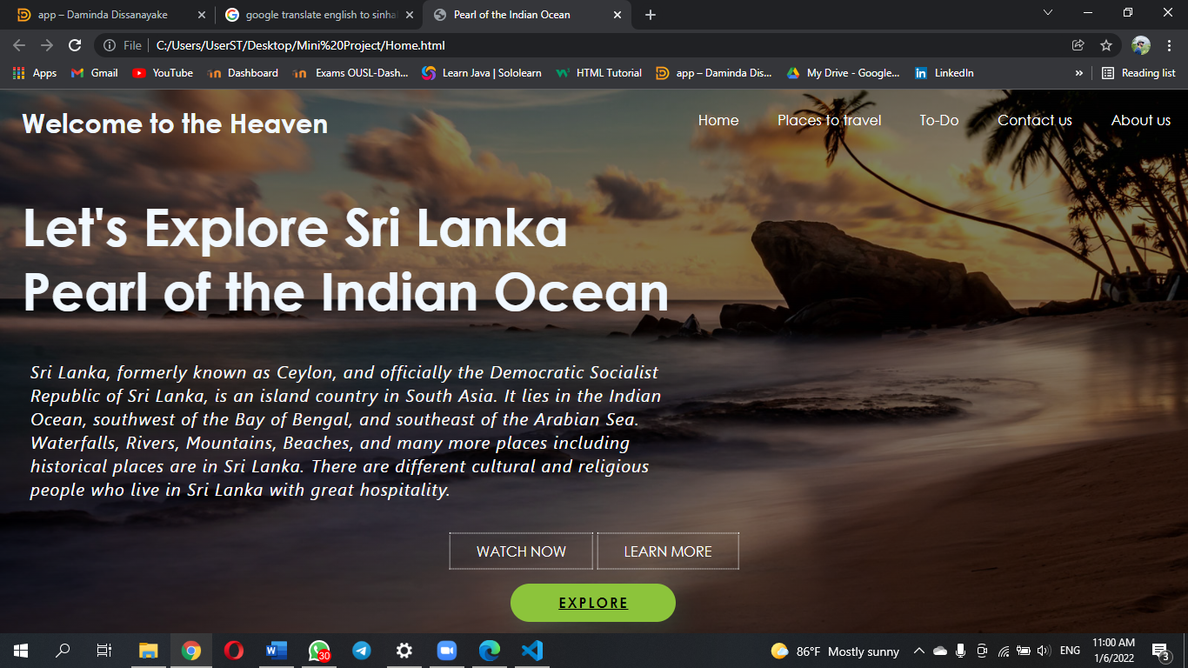

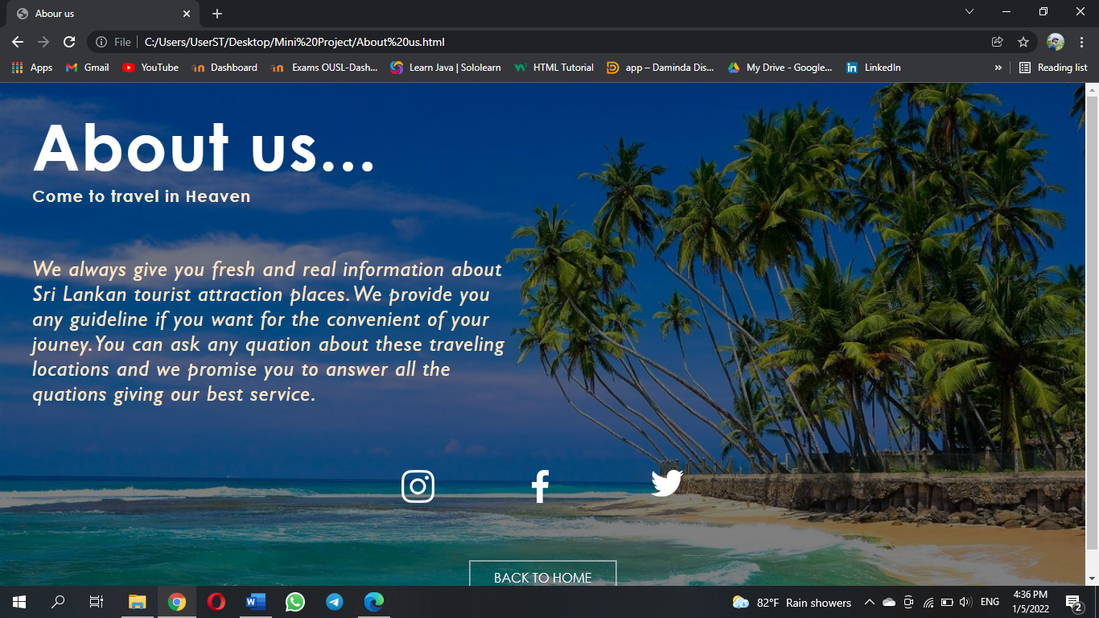

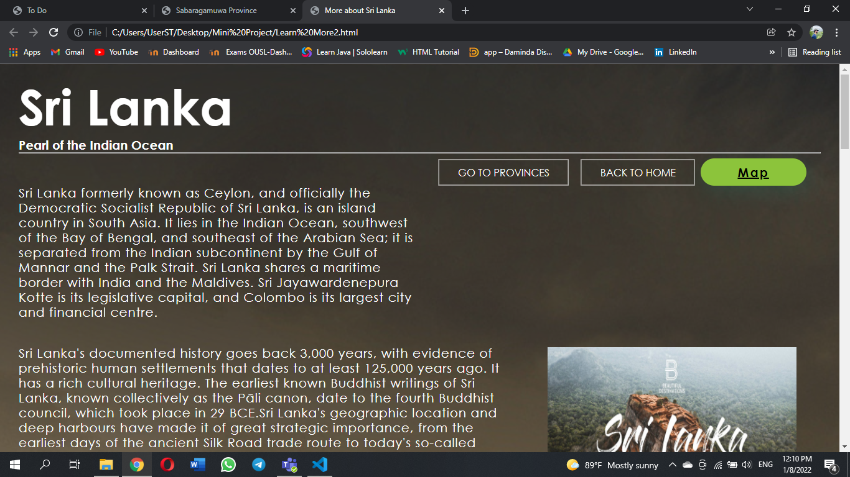

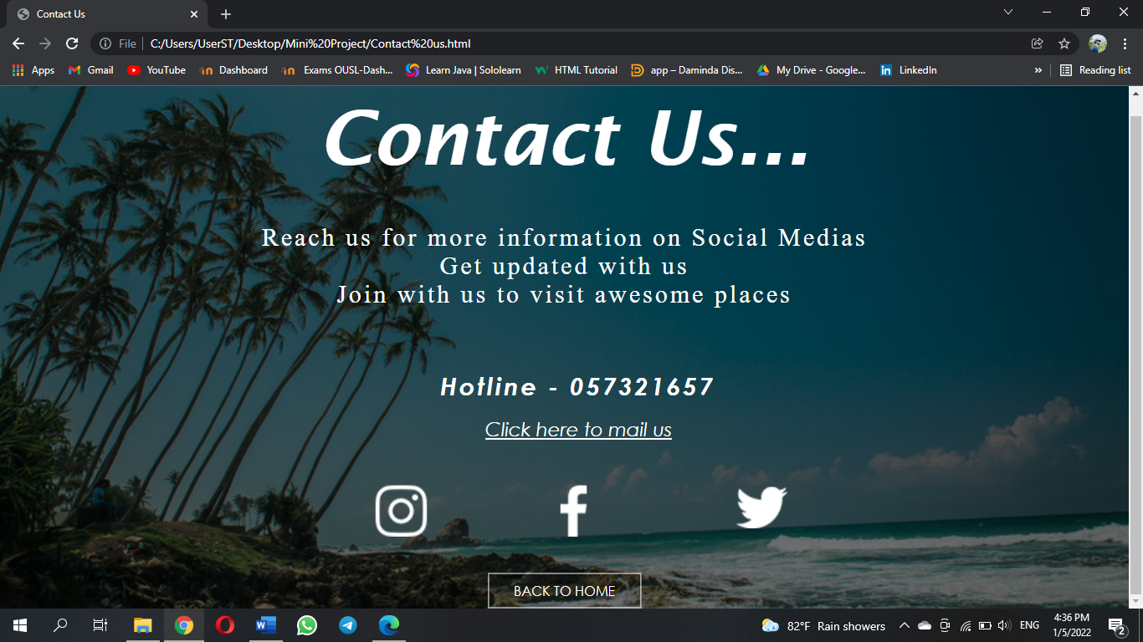

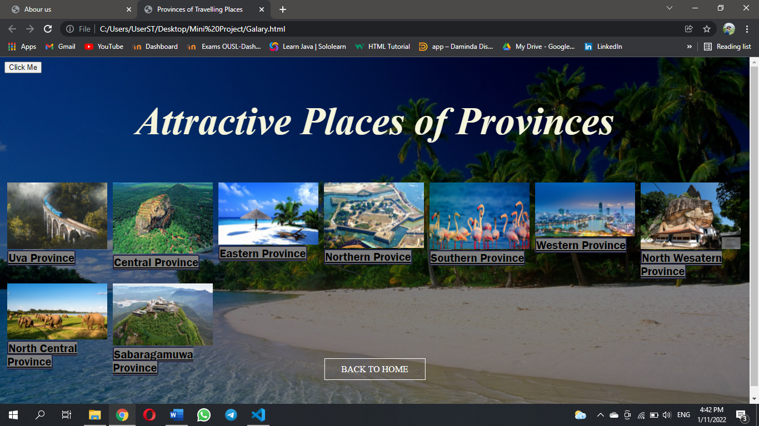

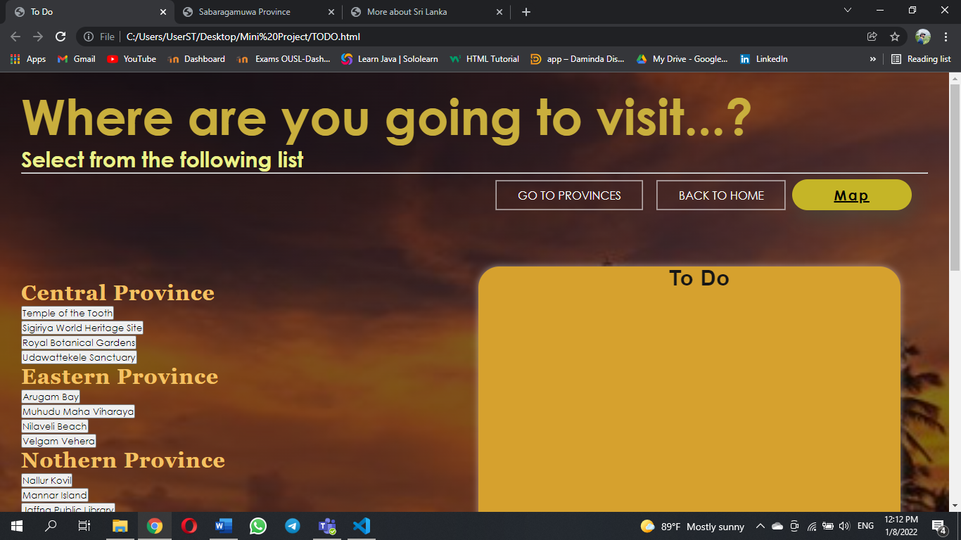

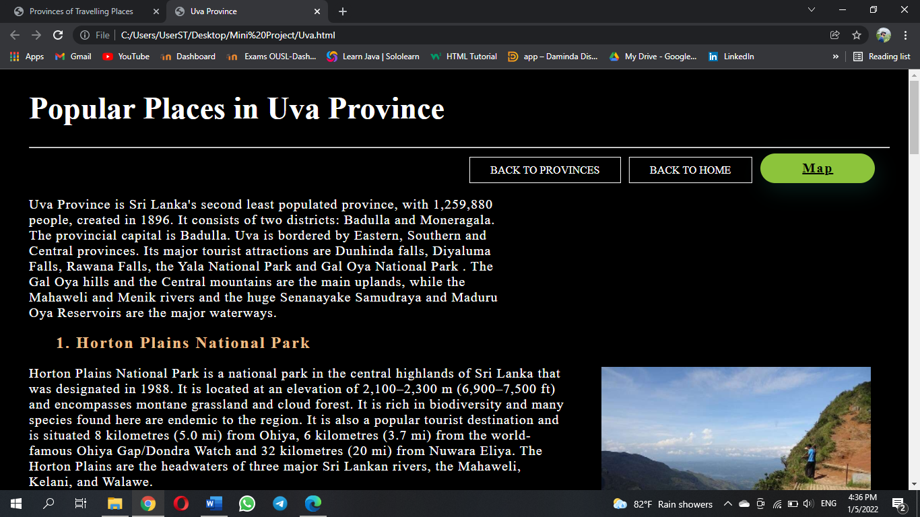

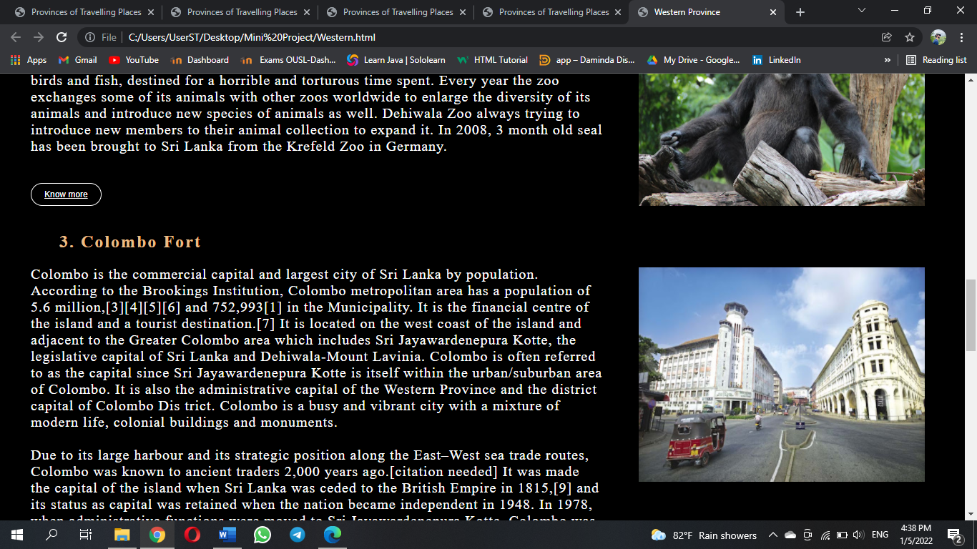

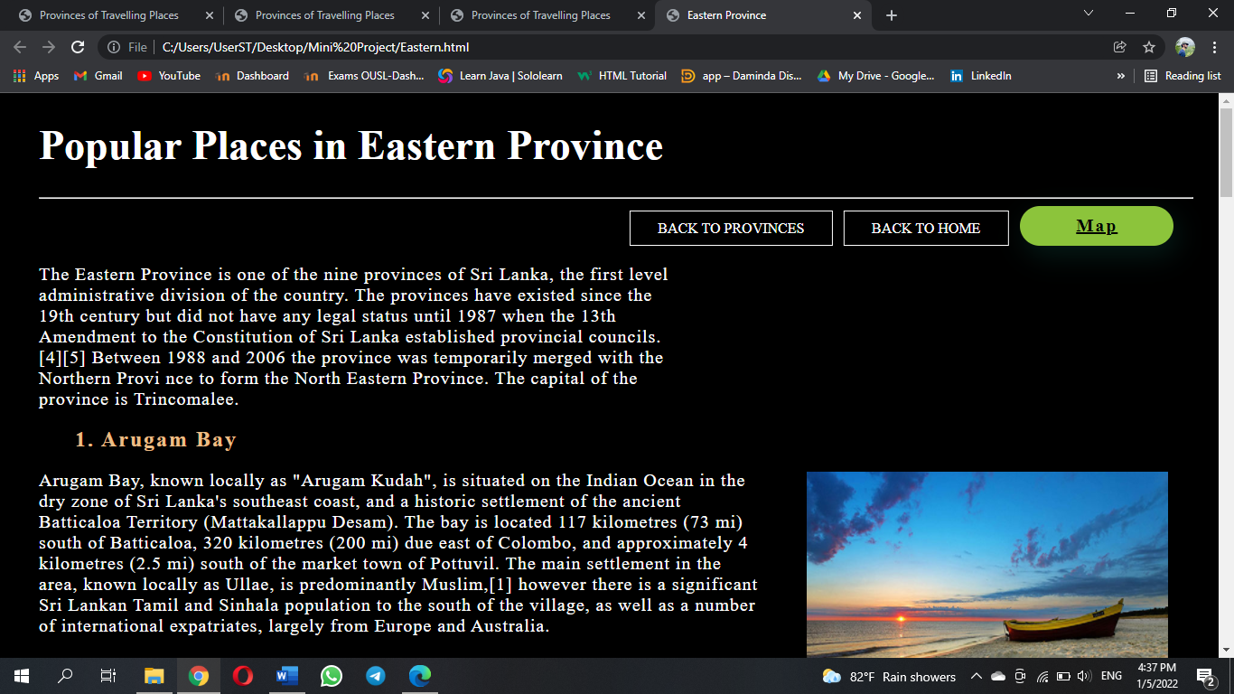

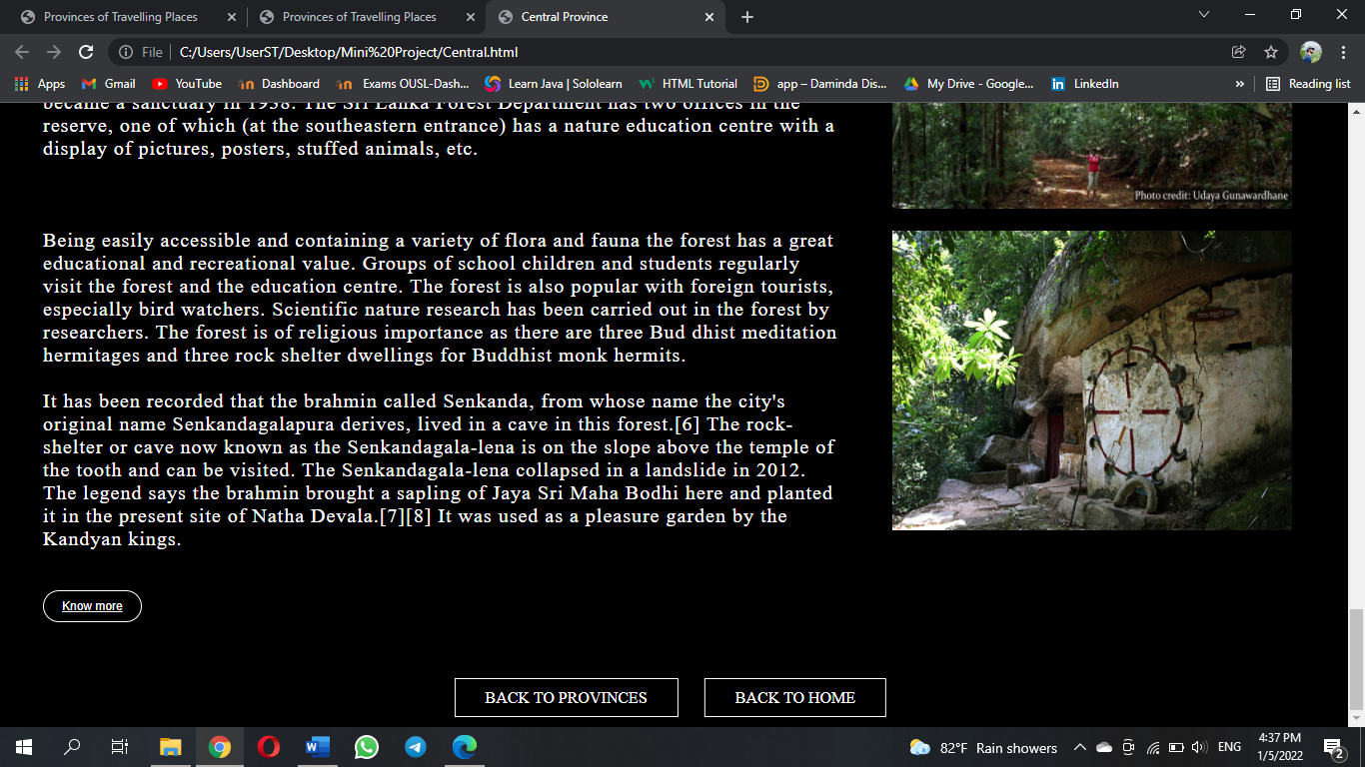

1. **References**

**The information of the places is included by using these following web sites.**

* [**https://www.wikipedia.org/**](https://www.wikipedia.org/)
* [**https://www.destimap.com/**](https://www.destimap.com/)
* [**https://www.tripadvisor.com/**](https://www.tripadvisor.com/)
* [**https://www.trip.com/**](https://www.trip.com/)
* [**https://www.thrillophilia.com/**](https://www.thrillophilia.com/)

1. **Conclusion**

In this report, I have mentioned the basic information about this tourism website and its design. I have referred to many websites to get information about Sri Lankan tourist attractions that I have mentioned in references. Also, the process of the site is described in this report. The reader can understand the structure of this website through the site map and Architectural diagram of the system. In the same way, the screenshots of the site are also mentioned in this report.

**Thank You**